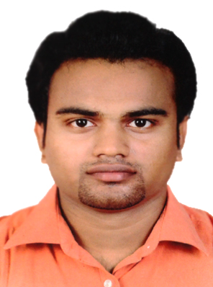

MOHAMMED SHAHEEM K V

Cheriya chandipurathu (H)
Veliyancode (P.O),
Malappuram,
Kerala, India.
679579

Mob. No: +919495331642
E-mail : mskv4u07070@gmail.com,
mskv4u@live.com

OBJECTIVE

To work for a company that gives me a platform to develop new skill set, while utilizing my present knowledge which will surely be an asset for the organization.

ACADEMIC PROFILE

Stream | Institution | University/Board | Year of Passing | Percentage/ CGPA
Bachelor of engineering in Mechanical Engineering | OAS Institute of Technology and management,  Trichy. | Anna University,  Chennai | 2010-2014 | 7.33  ( CGPA )
Higher Secondary | M.I.H.S.S Ponani | State Board, Kerala | 2008 | 74%
S.S.L.C | M.I.H.S.S Ponani | State Board, Kerala | 2006 | 85%

TECHNICAL SKILLS

Operating System : Windows Xp, Vista, Windows 7 and Windows 8.
Packages : MS office (Word, Excel and Power point), Photoshop,
Elementary knowledge in AUTO CADD, PRO/ENGINEER, ANSYS

PLANNING SKILLS

Planning & Project management : Skilled in Project Planning using PRIMAVERA P8

RESPONSIBILITIES HELD

- Served as Malayalee student representative of our college since January 2011.
- Captained the sports team for the year 2010.
- Designed a logo for the Mechanical Department of our college.

SIGNIFICANT ACHIEVEMENTS

- Won 1st prize in English Speech during the Annual day cultural program organized by the college.
- Presented a paper titled “Modification in solar water heater design” in the National conference conducted by the S.A Engineering College on 21-02-2014.

TRAININGS ATTENDED

- Certificate course of Computer society of India.
- One day workshop on RECENT TRENDS IN ROBOTICS AND RENEWABLE ENERGY SOURSE (SOLAR) on 25.02.2013 at Imayam College of Engineering, Trichy, Tamilnadu.
.

ACADEMIC PROJECTS

- Mini project on Design and fabrication of Multi braking system in two wheelers using single lever.
- Project Titled “Development of hybrid nano / reinforced surface MMC on Al7075 using FSP route” as the main project for the U.G

EXTRA-CURRICULAR ACTIVITIES

- Industrial visit to CIPET (Central Institute of Plastic Engineering and Technology) on 25-07-2013.
- Organized various intra college events and departmental activities.
- Organized the cultural fest of Onam 2013 celebrations.

DRIVING LICENCE DETAILS

Class of Vehicle : M/C With gr + LMV
License No. : 54/3204/2009

WORKING EPERIENCE

- Worked as a Medi-claim Agent of National Insurance Company through Sevak Health care services Changanachery during the year (2009-10).
- Served as Customer relations executive in Big Traders (a dealer of TATA TELE SERVICES) during the year (2008-9).

PASSPORT DETAILS

Type : P
Country Code : IND
Passport No. : M0786673
Place of Issue : Malappuram
Date of Issue : 12/08/2014
Date of Expiry : 11/08/2024
File No. : ML1067748909514

PERSONAL DETAILS

Father’s Name : K.V.MOIDUNNY
Date of Birth : 17th – April – 1991
Gender : Male

LANGUAGES KNOWN

ENGLISH, HINDI, MALAYALAM, TAMIL and ARABIC

DECLARATION

I do hereby declare that the particulars of information and facts stated above are true and correct to the best of my knowledge and belief.

Date: [Mohammed Shaheem.K.V]

Place: Veliyancode

